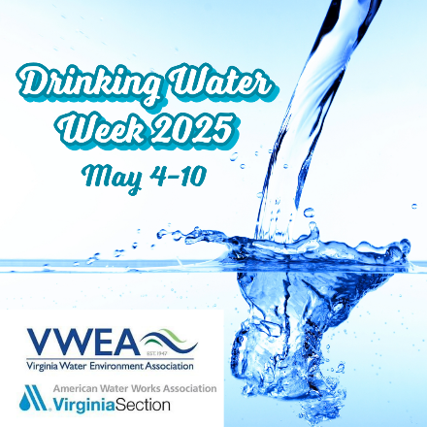

Drinking Water Week sample social media posts

Facebook
POST #1:
Welcome to #DrinkingWaterWeek 2025! This week, we celebrate the value of clean, safe water, the importance of water infrastructure, and the critical role of water professionals. Stay tuned for insights into the daily miracle of safe drinking water and how to celebrate it!

POST #2:
During #DrinkingWaterWeek, we honor the engineers, scientists and all water professionals dedicated to our water's safety. Their expertise and innovation ensure every drop we consume is clean and safe. Let's celebrate their commitment to our health and well-being.

POST #3:
This #DrinkingWaterWeek, take the opportunity to learn about your local drinking water. Discover its journey from its source to your faucet, and the efforts that go into ensuring safety and high quality. Understanding our water is the first step to conserving and protecting it.

POST #4:
As #DrinkingWaterWeek 2025 concludes, we reflect on the essential role of water in sustaining life and economy. Let’s commit to ongoing stewardship and investment in our essential water infrastructure.

Twitter/X
TWEET #1:
Welcome to #DrinkingWaterWeek 2025! Join us for a week of learning about the critical systems and people that deliver safe drinking water to our communities.

TWEET #2:
During #DrinkingWaterWeek, let's celebrate the dedicated individuals behind our safe drinking water. From engineers to operators to lab technicians and more, these professionals work tirelessly to ensure the quality and safety of our water.

TWEET #3:
#DrinkingWaterWeek is a perfect time to connect with your water's journey. Learn about your local water's source, its path to your tap, and the processes that ensure its high quality and safety.

TWEET #4:
Thank you for engaging with #DrinkingWaterWeek 2025. Together, let's continue to advocate for and invest in water – the world’s most vital resource.

Instagram
POST #1:
Welcome to #DrinkingWaterWeek 2025! This week, we celebrate the value of clean, safe water, the importance of water infrastructure, and the critical role of water professionals. Stay tuned for insights on the important work done by water utilities and how to celebrate drinking water!

POST #2:
From operators and engineers to environmentalists and scientists, we recognize the tireless efforts of our water heroes who safeguard public health and deliver reliable water service 24/7. #DrinkingWaterWeek

POST #3:
Make a difference during #DrinkingWaterWeek by volunteering with a local water conservation organization or by teaching your community about the importance of water sustainability.

POST #4:
Wrapping up #DrinkingWaterWeek 2025 with gratitude for our water resources and the community dedicated to preserving them. Here's to ongoing education and action towards water sustainability.

LinkedIn
POST#1:
This #DrinkingWaterWeek, we commemorate the 51st anniversary of the Safe Drinking Water Act (SDWA) – landmark legislation that revolutionized how we keep water safe every day. From setting national standards to fostering innovation, the SDWA has ensured clean, safe water for many hundreds of millions. Join us in celebrating SDWA’s achievements and advocating for continued investment in protecting water, the world’s most vital resource.

POST #2:
Every drop of safe drinking water reaching your tap represents the dedication and expertise of water professionals. This #DrinkingWaterWeek, we shine a light on these committed individuals – engineers, scientists, operators and more – who work tirelessly to ensure drinking water quality and reliability. Their commitment safeguards public health and economic prosperity. Let's express our gratitude to these unsung heroes!

POST #3:
Securing safe water access is not just an environmental or public health issue -- it's also a smart business decision. Reliable water infrastructure underpins economic growth, attracts investment and fosters vibrant communities. This #DrinkingWaterWeek, let's advocate for responsible investments in water infrastructure.

POST #4:
This #DrinkingWaterWeek, let's raise awareness and take action to assure water sustainability. Explore water conservation opportunities at your workplace, advocate for infrastructure investments, or support organizations promoting responsible water use. Every action – big or small – contributes to a more sustainable water future.

POST #5:
#DrinkingWaterWeek may be drawing to a close, but our commitment to water stewardship continues. We're grateful for your participation in raising awareness and advocating for solutions. Let's carry this momentum forward and continue building a more sustainable water future for all!

